Python Assignment 2 : Data Structures - List, Dictionary, Set
& Conditional Statements
Date of Submission : 02 - 10 - 2026
Name : K.Sreelatha

Screen shot:

List (Creation, Modification and Access):
1. List Creation

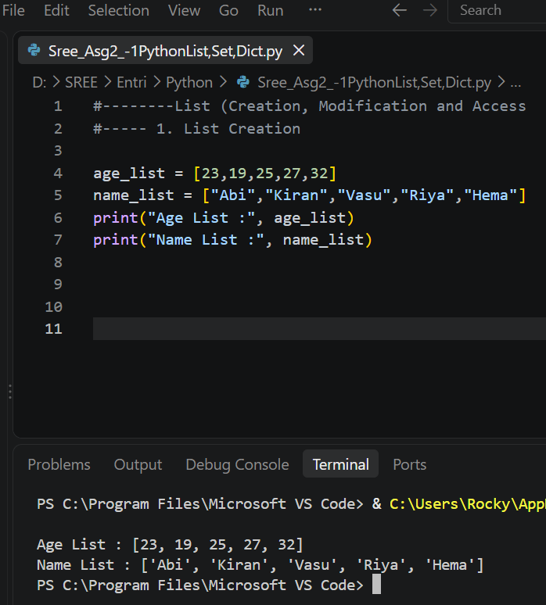

2. List Operations / Modifications

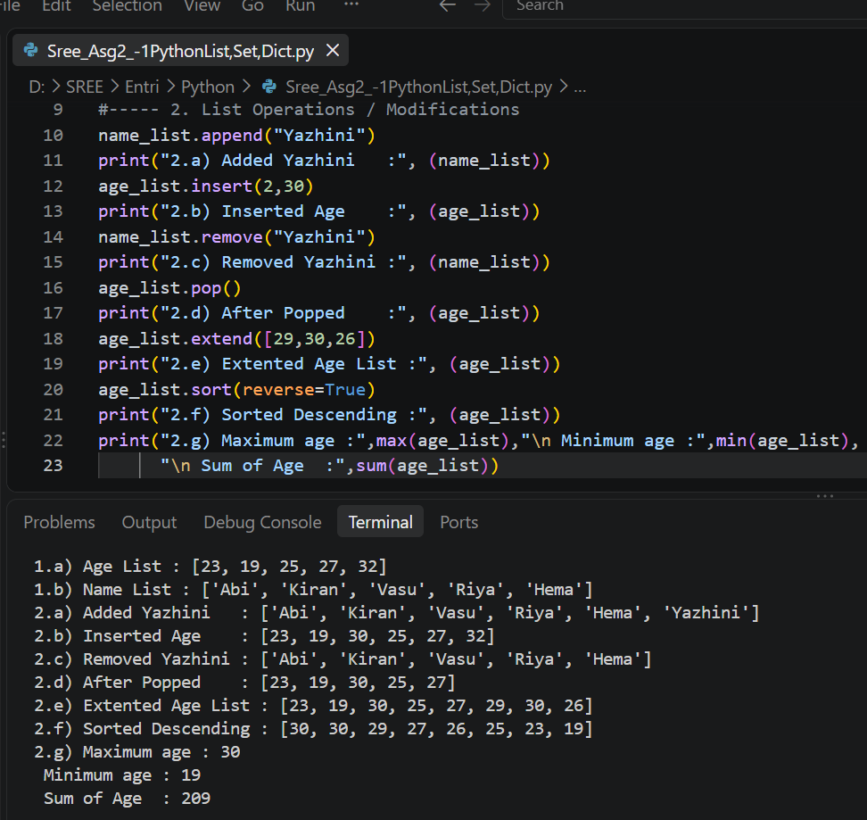

3. Accessing List Elements

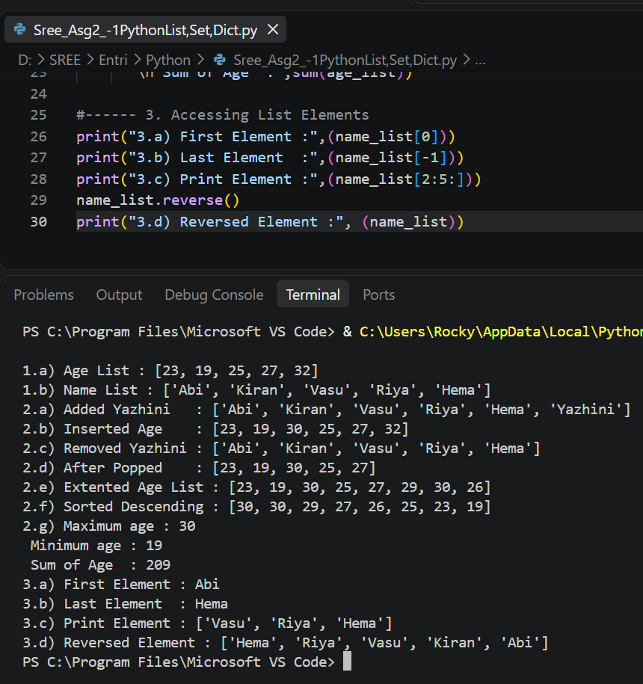

Dictionary (Creation, Modification and Access):

a. Create a dictionary named student_marks that maps the names of five students to their marks (use scale of from 0 to 100).

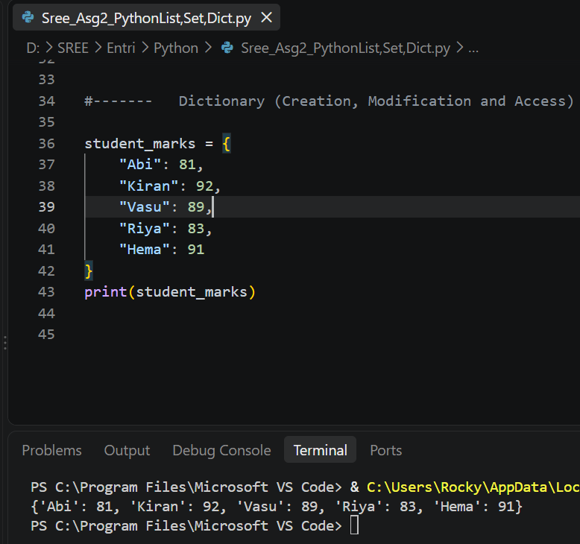

b. Access and print the mark of a specific student, of your choice.

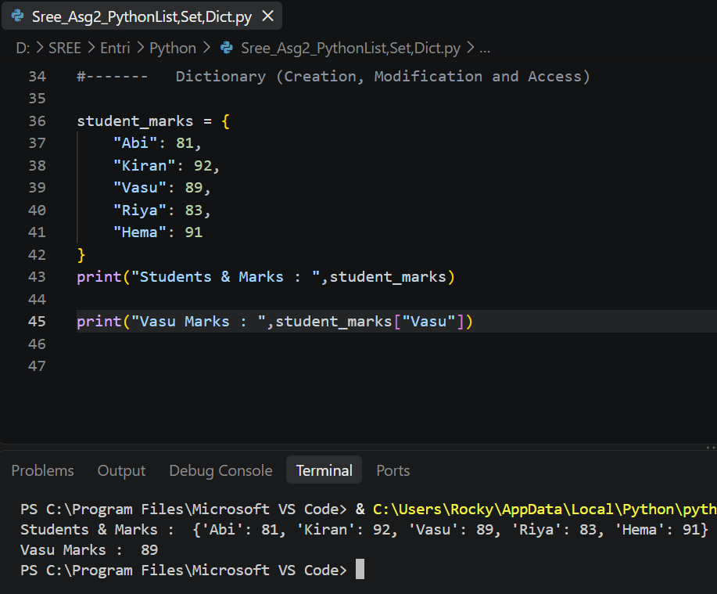

c. Add a new student "Janani" with a mark of 80 to the student_marks dictionary.

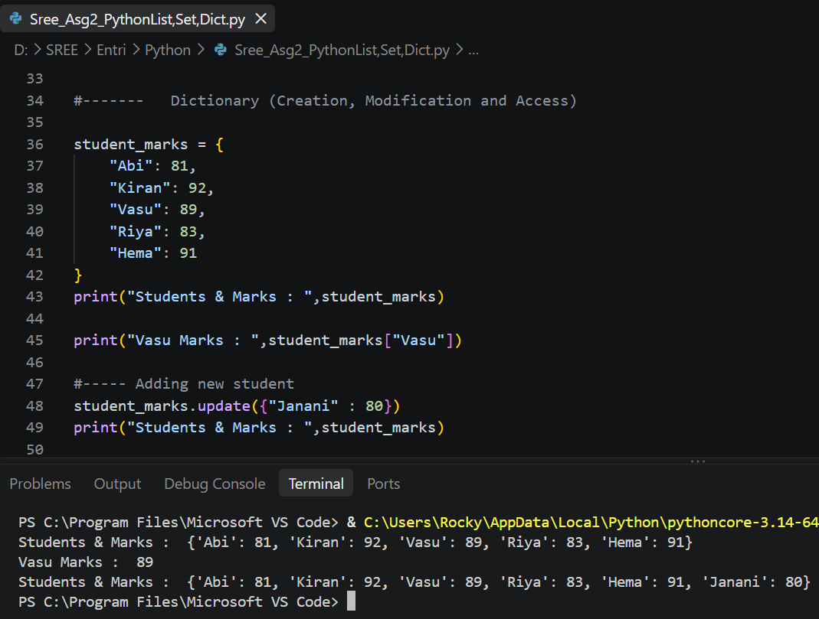

d. Update the mark of any one older student to 82.

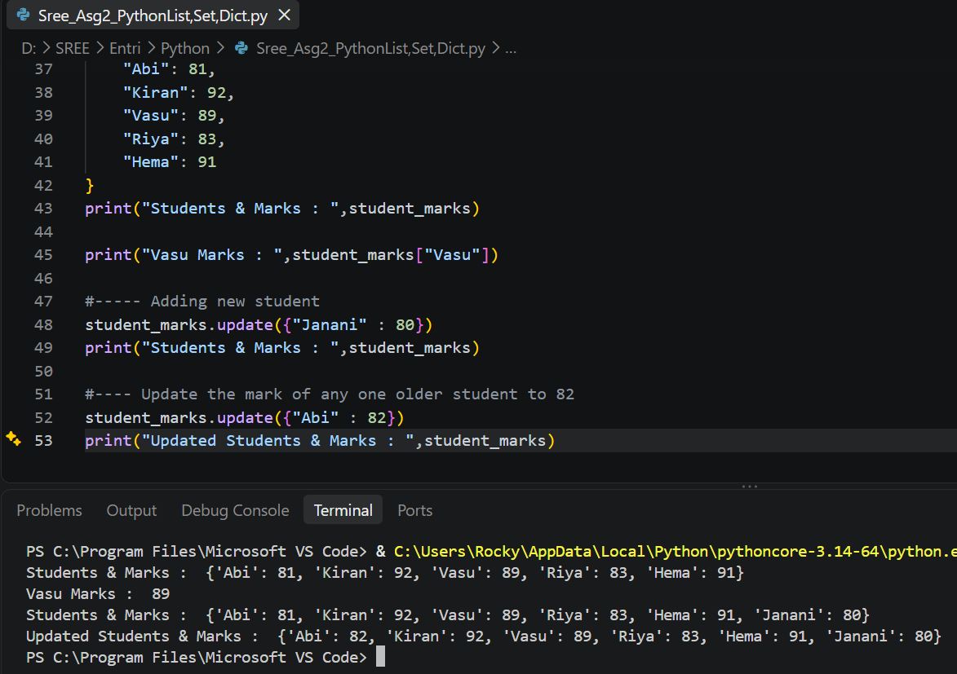

e. Use the keys(), values(), and items() methods to print all keys, values, and key-value pairs in the student_marks dictionary.

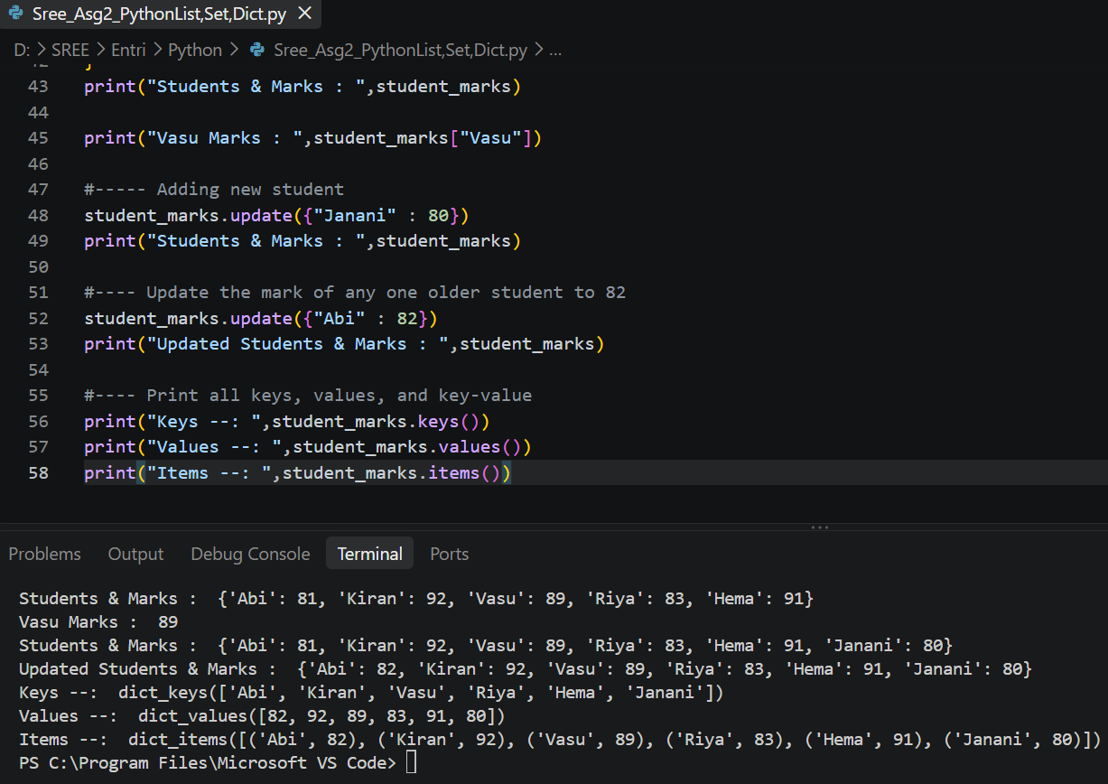

Sets (Operations)

a. Create a set called my_set with following values: ['a','e','i','o','u','a','a','i']. Analyse the output and provide explanation for the same.

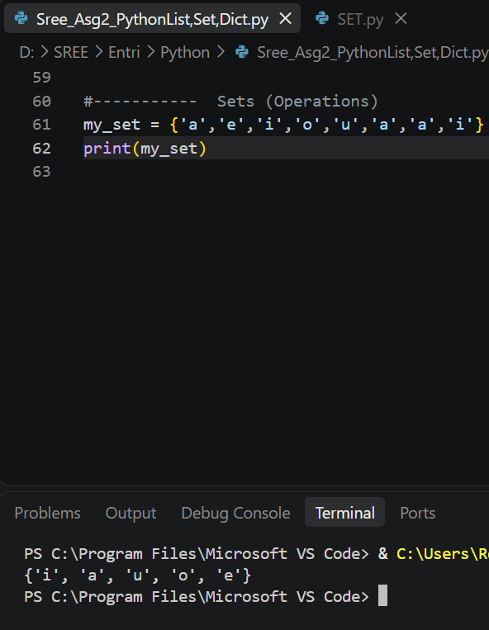

- A set stores unique values only.
- Duplicate values are automatically removed.
- In the given values, 'a' appears 3 times, and 'i' appears 2 times.
- The set keeps only one occurrence of each value.
- Therefore, the final set contains 5 unique values in unordered
b. Attempt to change the value of my_set[4] = 's'. If code throws an error, provide an explanation.

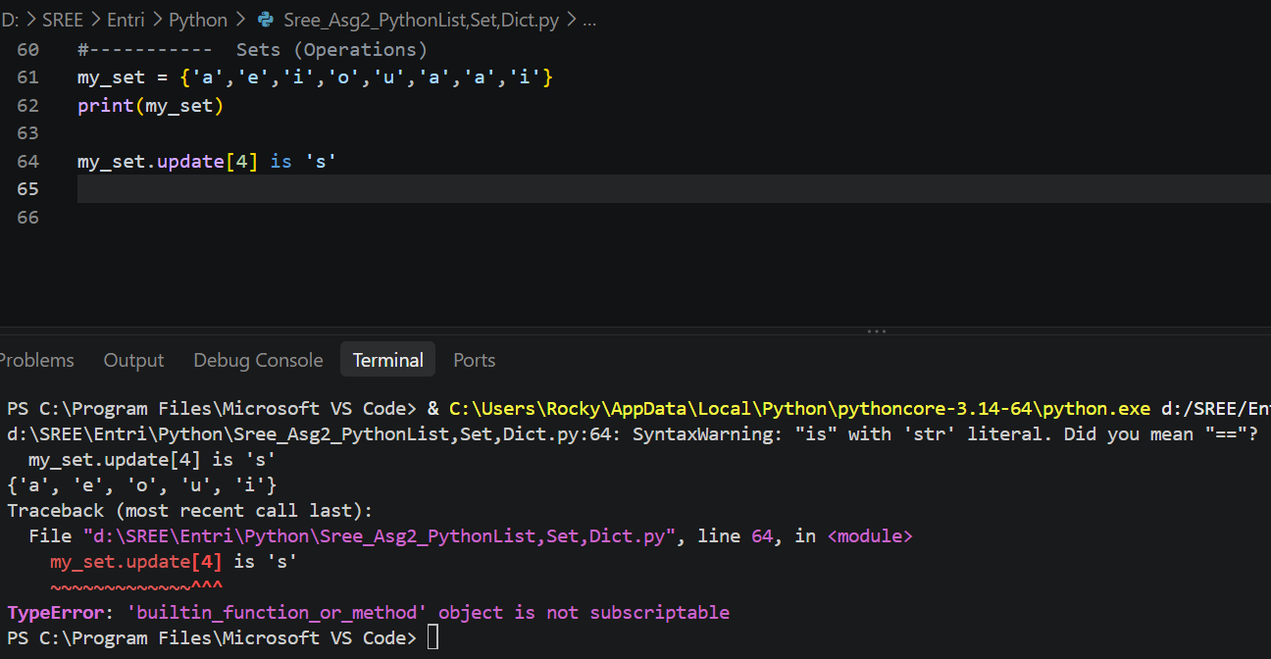

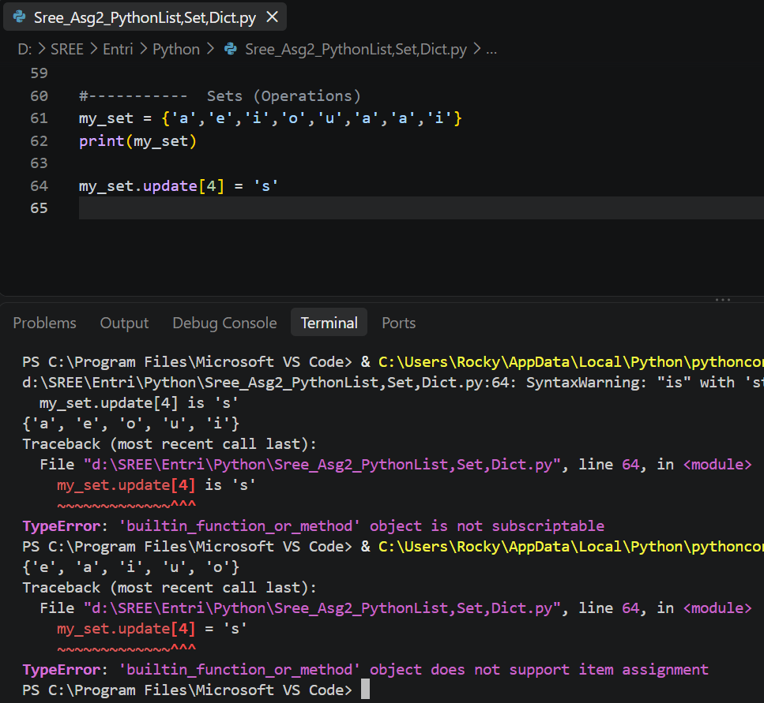

- A set is unordered, so it does not have positions or indexes like a list.
- Therefore, you cannot access or modify a set element using an index

c. Create two sets: set1 with values: {1, 3, 5, 7, 9} set2 with values: {2, 3, 5, 8, 10}

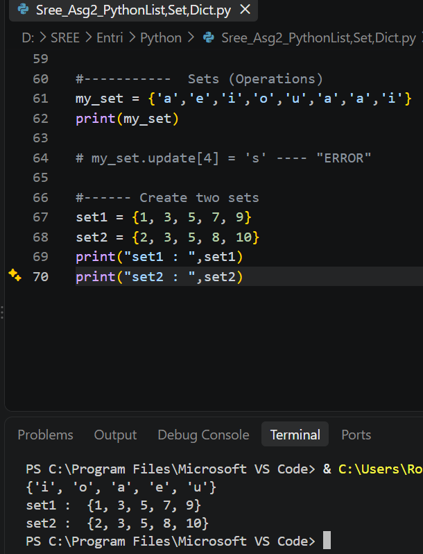

d. Compute and print the union and intersection of set1 and set2.

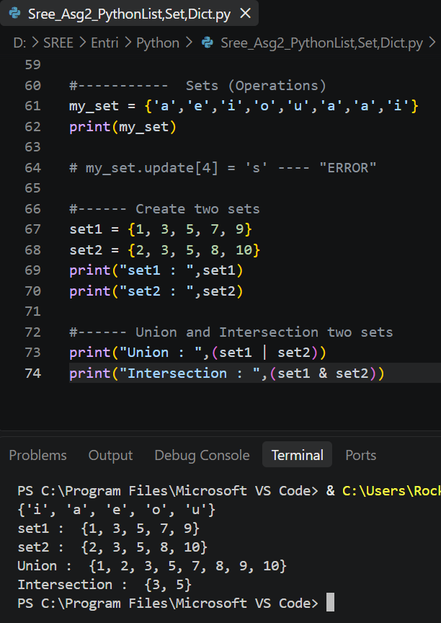

Operators & Conditional Statements :
(IF, ELIF, ELSE)

